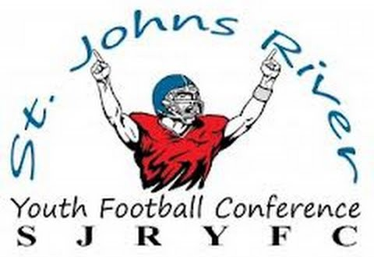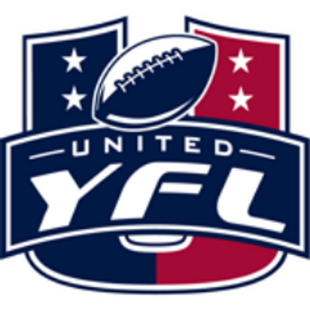

**St. John’s River Youth Football Conference**

**Parent/Adult Code of Conduct**

This Code of Conduct was developed to ensure an environment that encourages good behavior, fair play, respect, and fun. St. John’s Youth Football Conference requires all parents / adults to support and actively practice this Code of Conduct.

Parents / Adults shall:

* Be a positive role model for all participants and encourage sportsmanship by showing respect and courtesy, and by demonstrating positive support for all players, coaches, officials, volunteers, and spectators at every game, practice or other sporting event.
* Not criticize players/cheerleaders/coaches/volunteers in front of spectators or other participants, but reserve constructive criticism for later, in private.
* Not use abusive or profane language and/or gestures at any time.
* Accept decisions of the game officials and competition judges as being fair and called to the best ability of the officials.
* Not criticize an opposing team, its players, coaches, cheerleaders, or fans by word of mouth or by gesture.
* Not incite unsportsmanlike conduct.
* Learn the rules of the game and the policies of the league.
* Refrain from coaching my child(ren) or other players during games and practices, unless you are one of the official coaches of the team.
* Abstain from the possession and drinking of alcoholic beverages, and the possession or use of any illegal substance on any field or in any facility used by our participants.
* Not smoke and/or use smokeless tobacco on any field or in any facility used by our participants.
* Follow all county posted rules and regulations.

Failure to abide by the aforementioned rules and guidelines will be subject to disciplinary action that could include, but is not limited to the following:

* Verbal warning by official, head coach, and/or head of league organization
* Ejection from the SJRYFC event.
* He or she may receive a written warning regarding their behavior.
* His or her child(ren) may be removed from the SJRYFC event.

In the event that the game / activity has completed at the time of the infraction the parent / adult will be suspended for the next upcoming game / activity.

The parent / adult will be suspended until re-instated by the Conference board via a hearing to take place prior to the next scheduled game / activity, and only with approval of the sports board. Depending on the severity of the infraction the sports board has the option to suspend the parent and his or her child(ren) for multiple games / activities.

Any adult that commits a second similar offense will be banned from SJRYFC events for the remainder of that season and their child(ren) may be removed from the SJRYFC sport for the remainder of that season.

The parent / adult will be suspended until re-instated by the Conference board via a hearing to take place prior to the next season, and only with approval of the Conference board.

Any adult who threatens or physically assaults an official, coach, or SJRYFC volunteer will be banned from all SJRYFC sports / activities, and their child(ren) may be removed from the SJRYFC program for one year from the date of the offense. The child(ren) may not participate in any SJRYFC sponsored sport during the sanction period. After one year, the parent may apply for re-instatement. If the adult commits a second offense, he or she will be permanently banned from SJRYFC and the child(ren) may be permanently removed from participating in any SJRYFC sports / activities.

The term physical assault includes, but is not limited to: hitting, slapping, pushing, spitting, kicking, or striking in any way with any part of the body or any physical implement.

* Game forfeit through the Official / Coach or Conference Administrator
* Penalties may be imposed across sports / activities
* Written documentation of all incidents will be kept on file by the organizations involved

**By signing below you acknowledge receipt and adherence of the Code of Conduct set forth by St. John’s River Youth Football Conference.**

Association Name: _______________________________________________________

Name (Printed):___________________________________________________________

Name (Signature): ________________________________________________________

Date: _______________________________________________________________________